IFG Explore – 2nd Year
Term 2 – Week Three Kites Physical

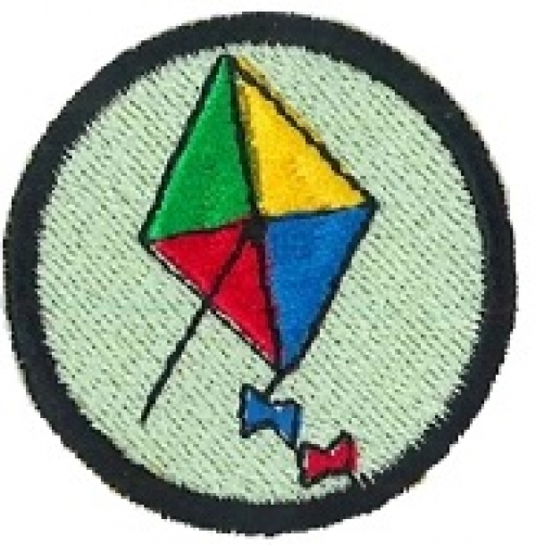
Aim: To develop construction skills in making and flying kites.

Objectives:
- Each girl will construct a simple kite.
- Fly the kite

Preparation:
- Balloons for devotions
- Equipment for making the kite

Pre-SetUp:
- Set all equipment out prior to the beginning of the session

SetUp:
Usual set up, roll call etc.

Devotions:
Keep it Up:
Hold up a balloon. How many of you like balloons? (Let girls respond). I’ve brought a few balloons to give away. Who would like these balloons? Select one girl. (Name of girl), you may have all these balloons if you can just keep them up in the air for one minute. Do you think you can do that? Let the girl respond. I’ll throw the balloons into the air, and all you have to do is keep them up. The rest of us will cheer for (name). Throw the balloons into the air and lead the girls in cheering. The balloons will fall before time runs out.
That’s too bad. I really wanted to give (name) my balloons. Maybe if we all help, we can keep the balloons in the air. Then everyone can have a balloon. Let’s try that, are you ready to go? Throw the balloons into the air while cheering the girls on.
When a minute has passed, call the girls back for the rest of the message.
God want his people to work together – just like when we all helped keep the balloons in the air. (Name) couldn’t do it on her own, but all together we could. During these next two weeks we are going to construct and fly kites. Even though we will each built and fly our own kite, we may need to help each other hold things during the construction, and even to help to get our kite flying. It pleased God to see us all working together.
Prayer:

Teaching Session:
A little history and background about kites:
Kites have been used by many cultures to celebrate special events and occasions. Kites have been around for two thousand years. It is not known for sure who or where the kite was invented, but China is credited with the invention because they were the first to record their use in legends. Japan and Thailand and other countries also recorded the use of kites in their legends. Marco Polo, the great explorer introduced the kite to Europe in the 13th century. The kite was mostly used as a children's toy, but it was later used for scientific purposes: Benjamin Franklin used it to show that electricity was present during a storm, and it was also used to record temperatures. It has also been used for military purposes.

Here are some special celebrations that kites are used in:
The Cherry Blossom Festival in Japan celebrated in April.
To celebrate spring in Japan, people have picnics under the blossoming cherry trees and children fly colourful kites.
Children's Day in Japan:
This is also another special occasion for celebrating and flying kites and traditionally the kites are in the shape of a carp fish.
Chinese New Year (Spring Festival) - the kite is a Chinese invention.

Kite Flying Safety Tips
It is important to share some safety advice with the girls before embarking on the kite flying.

Never fly a kite:
Near electric lines or poles.
With metal parts or lines which will attract electricity.
Use fishing line or wire to fly a kite
In the rain, the line can also carry electricity.
Near the edge of a steep hill or slope or too close to an airport.
Near ditches, stones, trees, and traffic or animals.
Making a paper kite:
Equipment:
- 20 sheets of brightly colored A4 size typing paper.
- 20 20cm bamboo bar-b-que shishkabab sticks.
- 1 roll of florescent surveyor's flagging plastic tape (available at any hardware store).
- A plastic bag cut in a 1" wide spiral all around will also make a great tail.
- 1 roll 1/2"wide masking tape or any type of plastic tape..
- 1 roll of string. (At least 3 metres long for each child.)
- 20 pieces of 8cm x 2.5 cm cardboard on which to wind the string.
- Scissors.
- Hole punch. (optional)
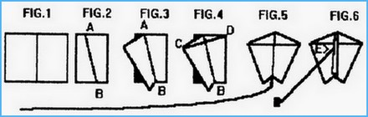
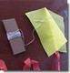
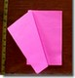
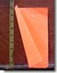
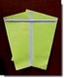
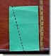
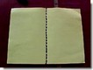

Directions:
- Fold a sheet of A4 paper in half
- Fold again along the diagonal line A in Fig.2
- Fold back one side forming kite shape in Fig.3 and place tape firmly along fold line AB.(No stick is needed here because the fold stiffens the paper and acts like a spine.)
- Place bar-b-que stick from point C to D and tape it down firmly.
- Cut off 1 to 2 metres of plastic ribbon and tape it to the bottom of the kite at B.
- Flip kite over onto its back and fold the front flap back and forth until it stands straight up.(Otherwise it acts like a rudder and the kite spins around in circles.)
- Punch a hole in the flap at E, about 1/3 down from the top point A.
- Tie one end of the string to the hole and wind the other end onto the cardboard string winder.
Now go flying!!

Closing prayer

Notices

Home

IFG Explore – 2nd Year
Term Two – Week Four Kites

Aim: To develop construction skills in making and flying kites.
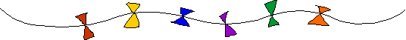

Objectives:
- To construct a kite with more detail
- Fly the kites
- Have a competition as to whose kite can fly the highest, longest time etc.

Preparation:
- Gather resources for making tonight’s kite
- Organise kite flying competition

Pre SetUp:
- Set out equipment for making the kites

SetUp:

Usual setup, roll call etc.

Devotions:

This devotion is aimed at a leader, not girl level, so please read it, and then relate the message in it to the girls.

Not too long ago I went to kite-a-flyin’ with my friends. I came home that night and penned a thanksgiving prayer. As I look at the experience of kite-flying, I find a vivid illustration of faith and futility. I took it and ran all over the field. Sometimes it went up a little. Sometimes a breeze would blow the kite in the direction I was running instead of against it. When I stopped running, the kite fell back to the earth, and I was left breathless and exhausted. And I had to wind up my string all over again.
After a long wait, A friend's kite caught the wind. And how it soared! Soon she was asking for more string, and marvelling at how effortless it was to fly a kite.
The Christian life is much like this. Often we find ourselves running about trying to get things right, particularly in the area of ministry. We come up with a great idea. We cannot wait to see it take off, and so we pour all our energies into it. But strangely it does not take off. There are hardly any results, and we are left disappointed and tired. And we have to pick up the pieces and start again. Our impatience has gotten the better of us. God gave us an idea, and we have taken it into our own hands. Instead of waiting for Him to move, we run ahead of Him. Instead of relying on Him, we depend on ourselves. No wonder our efforts come to nothing.
We must wait for God, and learn to depend on Him alone. Waiting may be the most difficult thing to do, but running ahead of God is far worse. Let God work in His own time. Depend on Him. It is the wind, and not us, that holds the kite up. It is God - not us - who initiates and sustains His work. Let us wait for Him that we may wait upon Him. And let us be patient and ready for His wind.

The prayer penned: Thank You for the stillness, for it taught us to wait for You; and the wind that made us realise that when You blow, and as we release, we can sort!

Teaching Session:

This kite consists of these basic parts:
- The Spine. The up-and-down, or vertical stick that you build your kite around.
- The Spar. The support stick(s), that are placed crossways or at a slant over the spine. Sometimes they are curved or bowed.
- The Frame. The joined spine and spars, usually with a string connecting their ends, that form the shape of the kite and make a support for the cover.
- The Cover. The paper, plastic, or cloth, that cover the frame to make a kite.
- The Bridle. One or more strings attached to the spine or spars, which help control the kite in the air.
- The Flying Line. The string running from the kites’ bridle, where you hold to fly the kite.
- The Tail. A long strip of paper or plastic of ribbon that helps to balance the kite in flight. Not all kites need tails.
- The Reel. The object you use to wind your flying line, to keep it form getting tangled or flying away.
Diamond Kite:
Materials:
- String thin garden twine
- scotch tape or glue
- 1 sheet of strong paper (102cm x 102cm)
- 2 strong, straight wooden sticks of bamboo or wooden doweling 90cm and 102cm
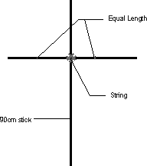
- markers, paint or crayons to decorate your kite.
How to Make:
- Make a cross with the two sticks, with the shorter stick placed horizontally across the longer stick. Make sure that both sides of the cross piece is equal in width.
- Tie the two sticks together with the string in such a way as to make sure that they are at right angles to each other. A good way to ensure that the joint is strong to put a dab of glue to stick it in place.
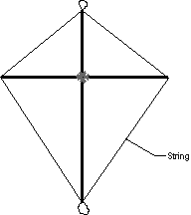
- Cut a notch at each end of both sticks. Make it deep enough for the type of string you are using to fit in to. Cut a piece of string long enough to stretch all around the kite frame. Make a loop in the top notch and fasten it by wrapping the string around the stick. Stretch the string through the notch at one end of the cross-piece, and make another loop at the bottom. Stretch the string through the notch at one end of the loop at the bottom. Stretch the string through the notch at the other end of the cross-piece. Finish by wrapping the string a few times around the top of the stick and cutting off what you don't need. This string frame must be taut, but not so tight as to warp the sticks.
- Lay the sail material flat and place the stick frame face down on top. Cut around it, leaving about 2-3cm for a margin. Fold these edges over the string frame and tape or glue it down so that the material is tight.
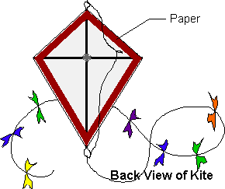
- Cut a piece of string about 122 cm long. and tie one end to the loop at the other end of the string to the loop at the bottom. Tie another small loop in the string just above the intersection of the two cross pieces. This will be the kite's bridle, the string to which the flying line is attached.
- Make a tail by tying a small ribbon roughly every 10cm along the length of string. Attach the tail to the loop at the bottom of the kite.
- Decorate!
Tips:
- A properly located pivot point is generally located slightly ahead of the centre of gravity.
- Cut away from you!
- Spray can glue is really good for patching up paper kites.
- Stability is improved by the use of an effective bow and a flexible tail.
- Hold your kite up by the string when you are finished to see if it is balanced. You can balance it by putting more paper on one side.
- Kites are different each time you make one, so slight adjustments might need to be made for each kite.

Kite flying competiton:
Now is the time to test those kites –
- Whose kite can fly the highest?
- Whose kite can fly for the longest time?
- Whose kite has the longest tail?
- Whose kite is the most colourful?
- Etc

Closing Prayer

Notices

Home

